Relation prevalence of obesity among adults and noncommunicable diseases
Author: Hendrik Reitsma
Final assignment programming 1
Date: 16-02-2022

Research question
Is there a relation between Prevalence of obesity among adults (BMI ≥ 25) and noncommunicable diseases (heart disease, stroke, cancer, diabetes, chronic lung disease), and where does The Netherlands rank on these factors compared to the rest of europe?
The sources used are datasets from the World Health Organization (WHO). The data can be found here^{[1]}. The datasets are freely available.

Risk factors for noncommunicable diseases (NCD) are, according to the WHO^{[2]}, the following:

- Blood glucose
- Blood pressure
- Cholesterol
- Insufficient physical activity
- Overweight / Obesity
- Alcohol

Methods
The aim is to find a clear correlation between countries’ overweight or obesity prevalence and NCD-mortality through comparing the datasets and to visually display the relevant plots in a dashboard. A Pearson correlation coefficient was computed to assess the linear relationship between obesity and NCD-mortality.

The Netherlands is compared to the rest of europe. The latest available data from 2016 is used.

Approach
Data storage and processing
The data is freely available on the website of the WHO so it can be made public. Only the average data is used to compare countries.

Analysis
The research question asks for a relation between two variables. Therefore, a Pearson correlation is used to find relations.

Data visualization
Scatterplots with a correlation line are shown to show the relationship between the variables. To show the difference between The Netherlands and the rest of Europe, a map is drawn with data circles to easily compare the countries.
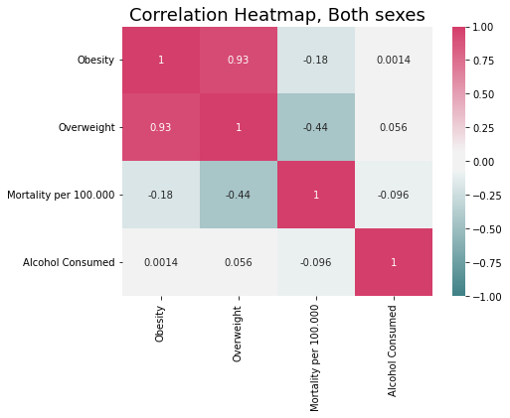Figure 1: Correlation heatmap with data from europe from 2000 through 2016.

Results
Pearson Correlation
There is a negative correlation (Figure 1) between obesity and mortality, r(746) = -.18, p<.01. The effect is greater for males (r(746) = -.47, p<.01) than females. Female only analysis does not yield a significant correlation.
In The Netherlands, there is also a negative correlation between obesity and mortality, r(16) = -.97, p<.01. The effect is greater for males (r(16) = -.98, p<.01) than females (r(16) = -.97, p<.01).
Ranking The Netherlands compared to Europe in 2016
Obesity: 20.4%, 35 out of 44;
Overweight: 57.8%, 24 out of 44;
Mortality per 100.000: 340.2, 32 out of 44;
Mortality/Obesity Ratio: 16.68, 25 out of 44;

Discussion
Significant reduction for males in obesity and ncd correlation between 2000 and 2016. Even though obesity is a risk factor for ncd mortality, the data showed a negative correlation. This can be explained by increasing obesity between 2000 and 2016 and in the same time frame increasing quality of healthcare. The result shows that health care is a more important factor than obesity.
For The Netherlands the same results are found, except for all sexes. In Europe, The Netherlands is ranked only 35 out of 44 countries in obesity prevalence and 32 out of 44 countries in ncd-mortality per 100.000.

Conclusion
The risk factor obesity does not necessarily correlate with ncd-mortality. Countries that have less ncd-mortality have increased healthcare and screen more for cancer or treat heart disease better (like coronary bypasses).
For further research, it is advised to compare countries with same healthcare system. For example, only choose countries that screen for cancer the same amount or treat heart disease in a similar way.

Sources:
[1]: https://apps.who.int/gho/data/node.main.A858?lang=en
[2]: https://apps.who.int/gho/data/node.main.A867?lang=en

